**PROJECT TASK 3**

**CONFIGURING SNORT IPS TO DETECT, MONITOR AND ALERT CYBERSECURITY ATTACKS**

Alabi Kehinde Oluwasemilore

Information Systems Engineering and Management, Harrisburg University

CISSC 661: Principles of Cybersecurity & Cyberwarfare

Dr. Bruce Young

28/05/2023

## Snort IPS Setup

Performed a successful exploit for this project. For this project we needed Kali Linux, Metasploitable.

**System Configuration:**

* Macbook Pro 2016
* Mac OS Ventura
* 32 GB RAM
* 2.3 GHz 8-Core Intel Core i9

**Step 1:** Test for connection

* Using Ping to test for connection.

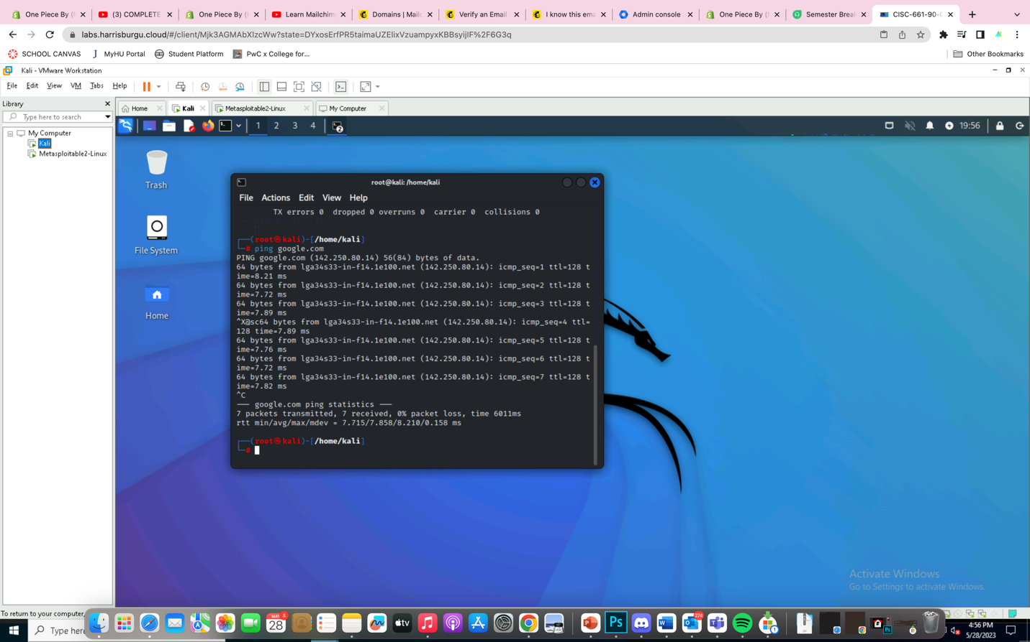

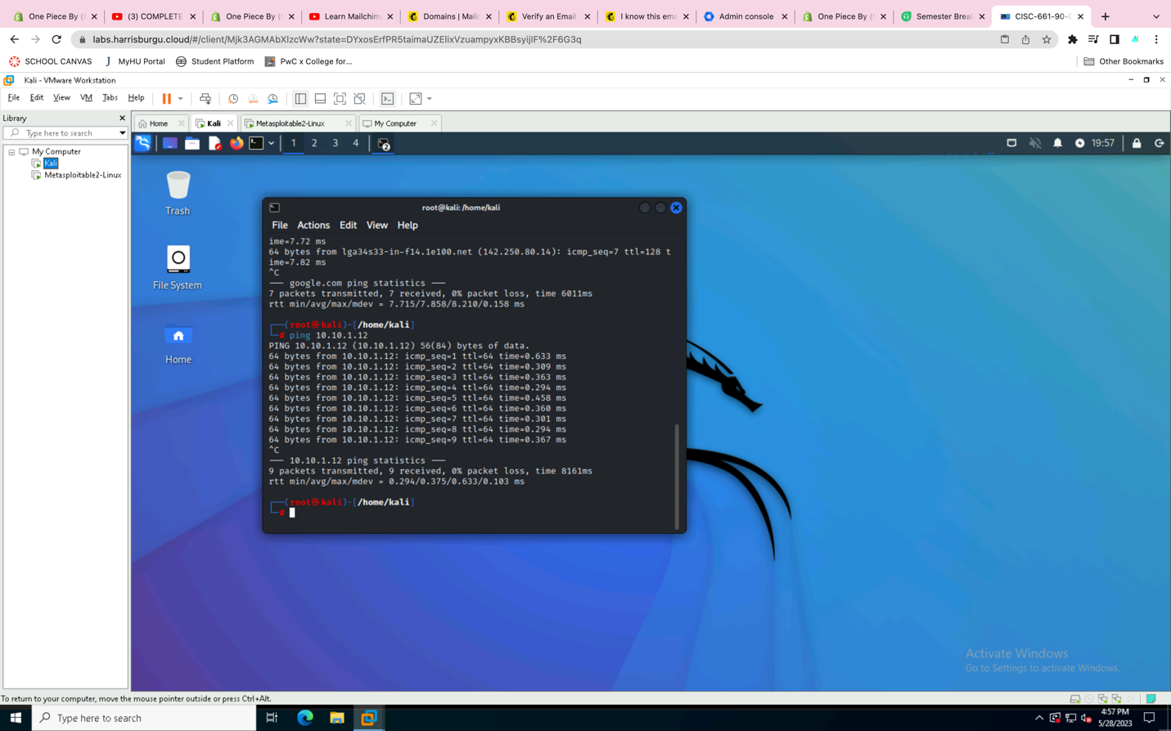

**Step 2**

* Move sources list by making backup copy

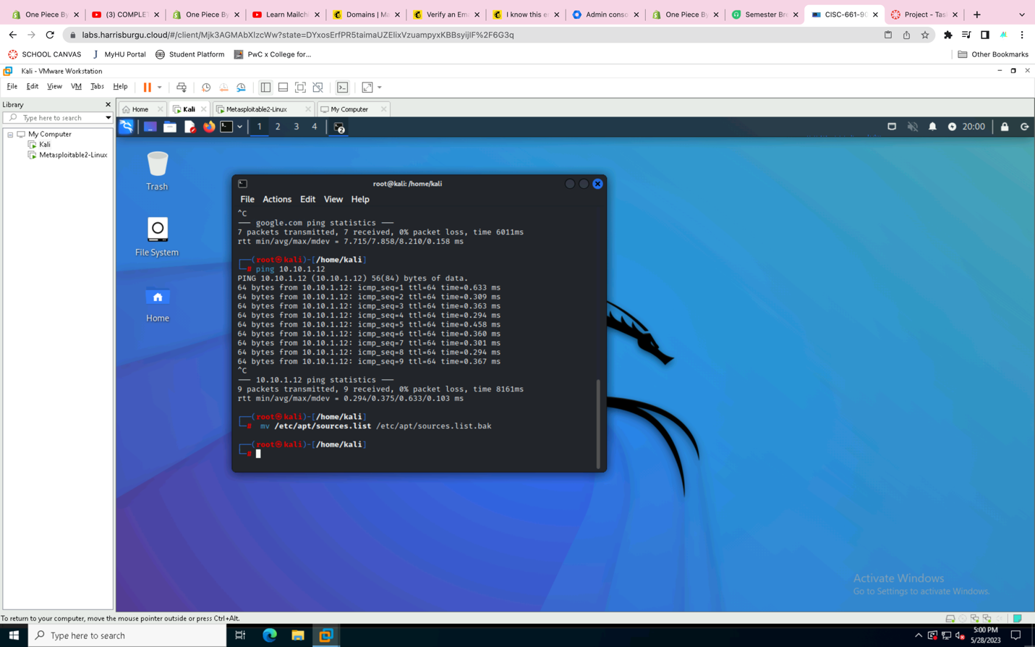

* Create certificate in place to ensure secure connection.

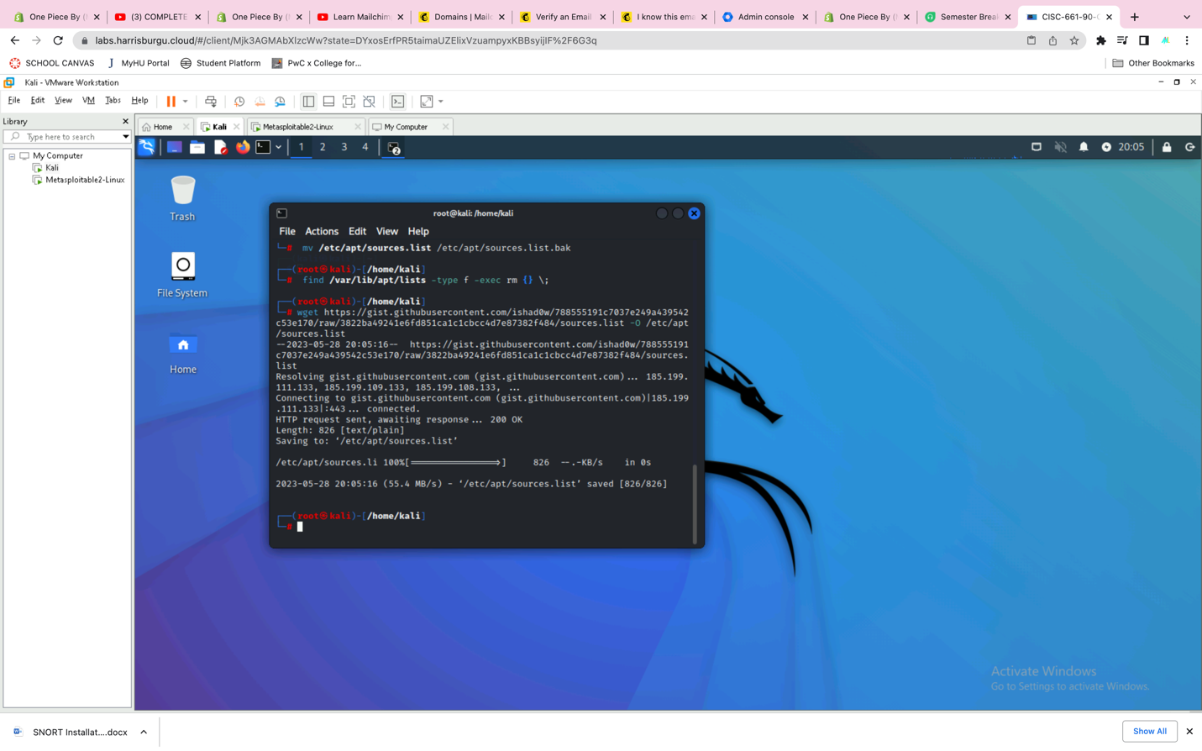

**Step 3**

* Perform apt update

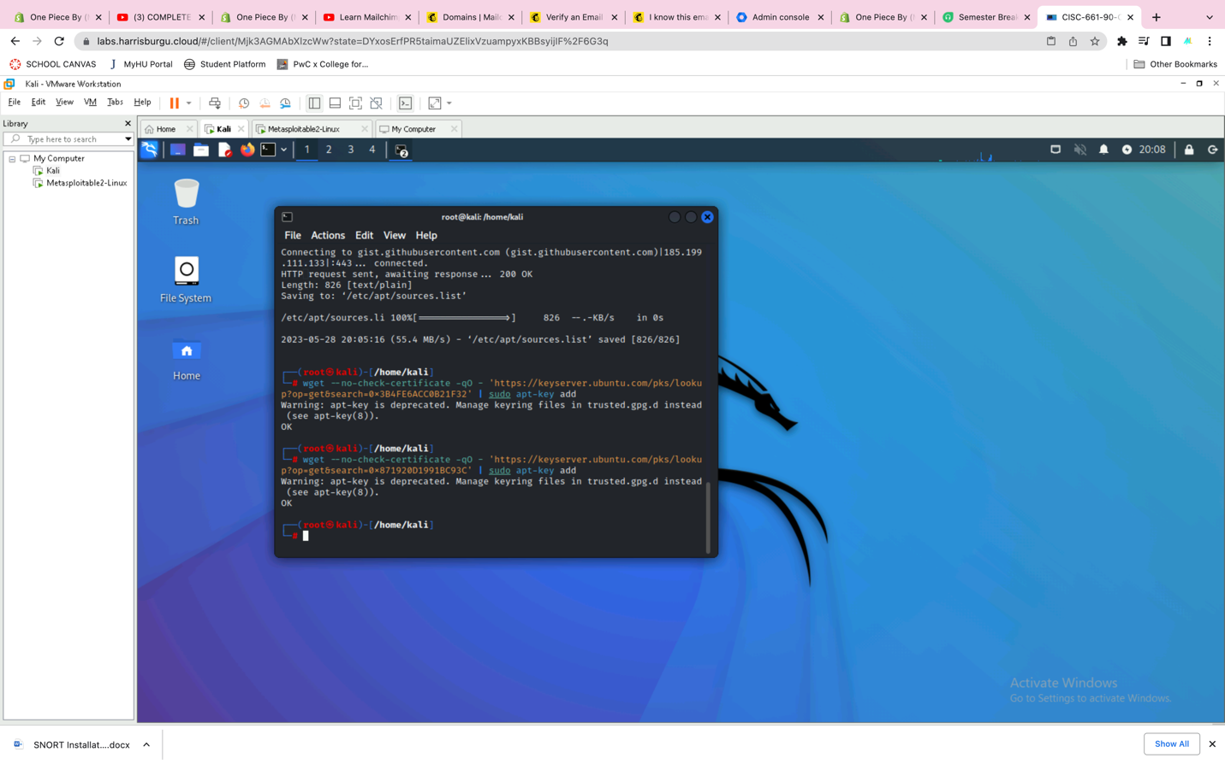

* Perform apt install snort.
* Change default network to local network

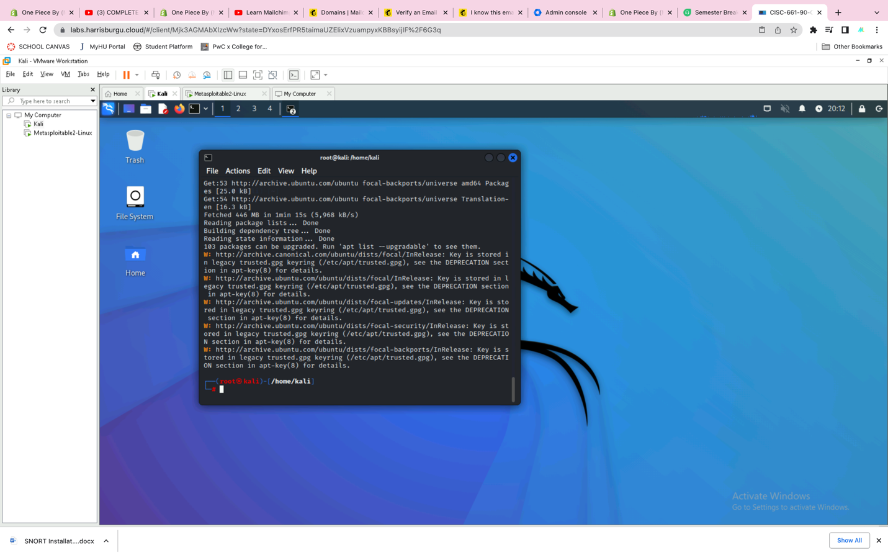

**Step 4**

* Move sources file back to original file by overwriting.
* Test configuration

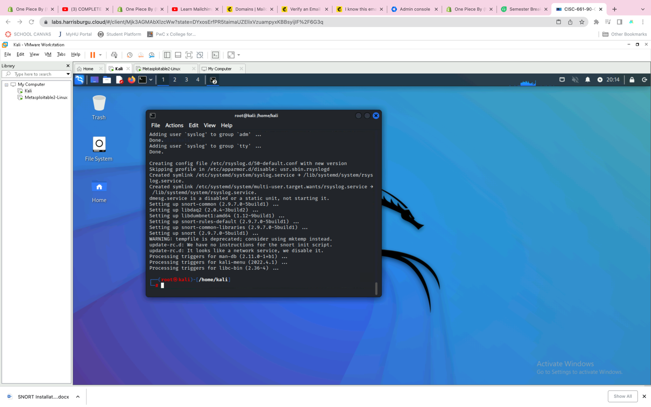

* Access directory where Snort is deployed.

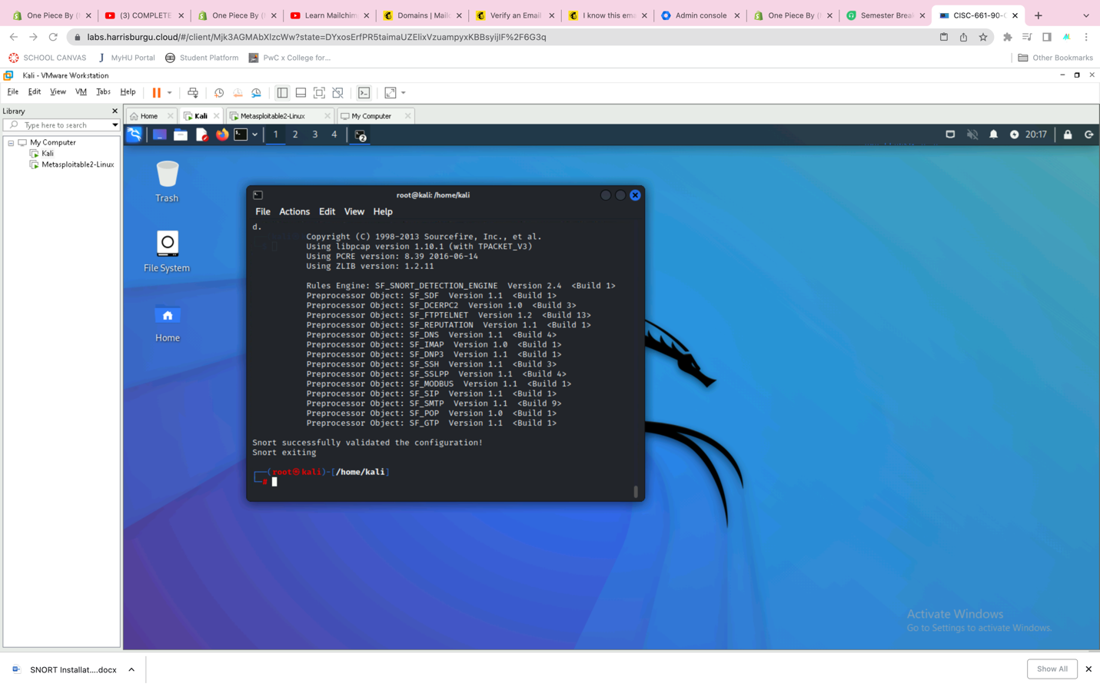

* Access rules file

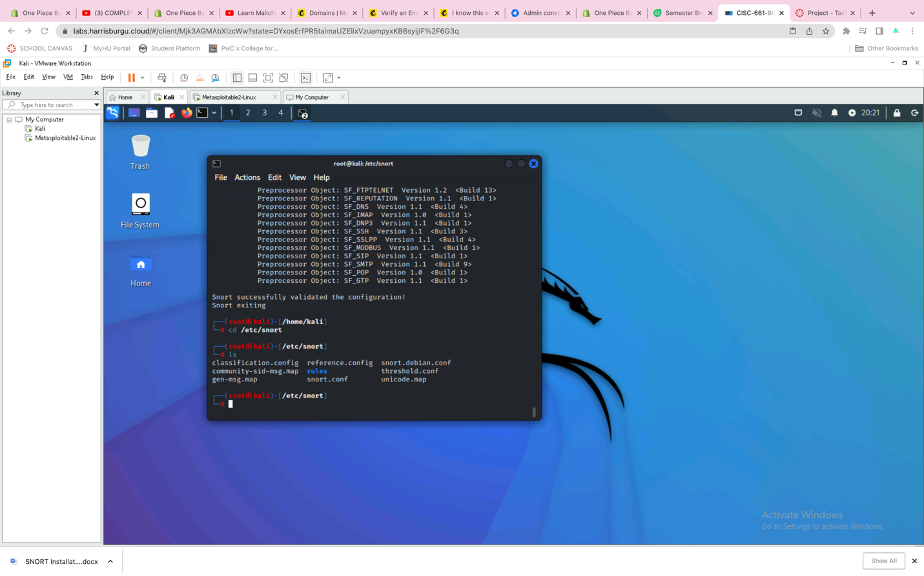

* Create syntax to detect activity using “telnet.rules”

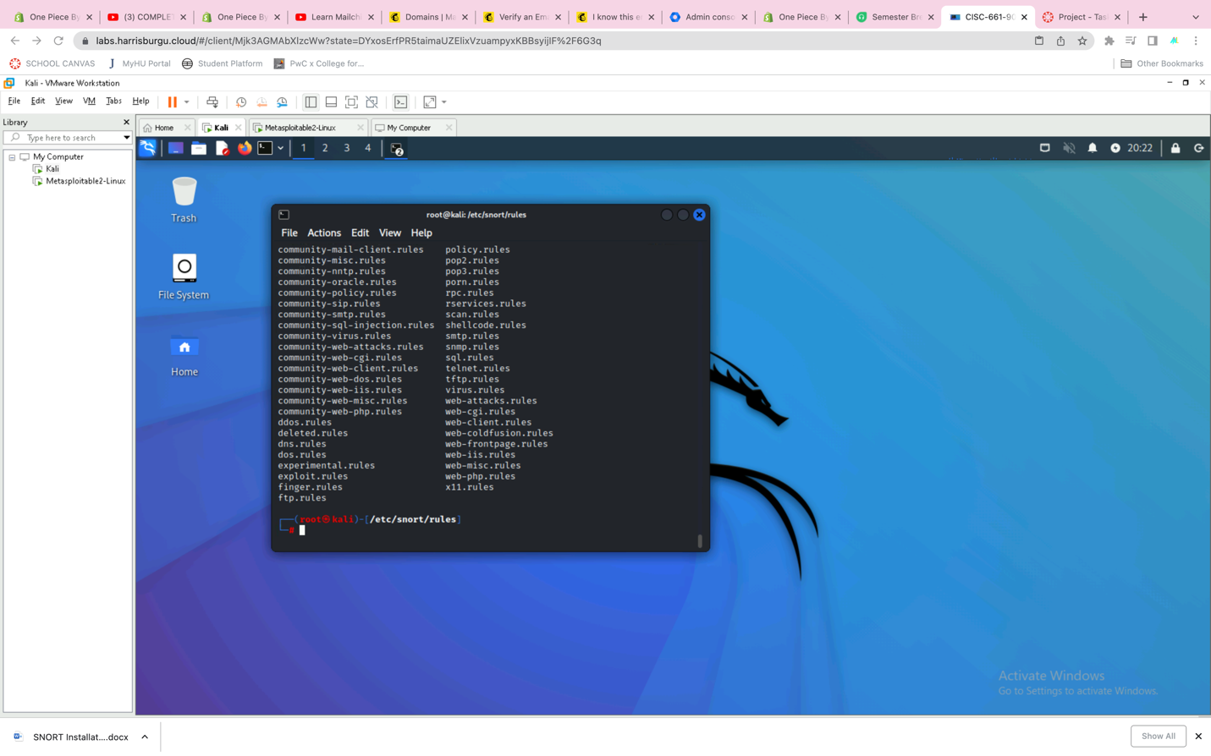

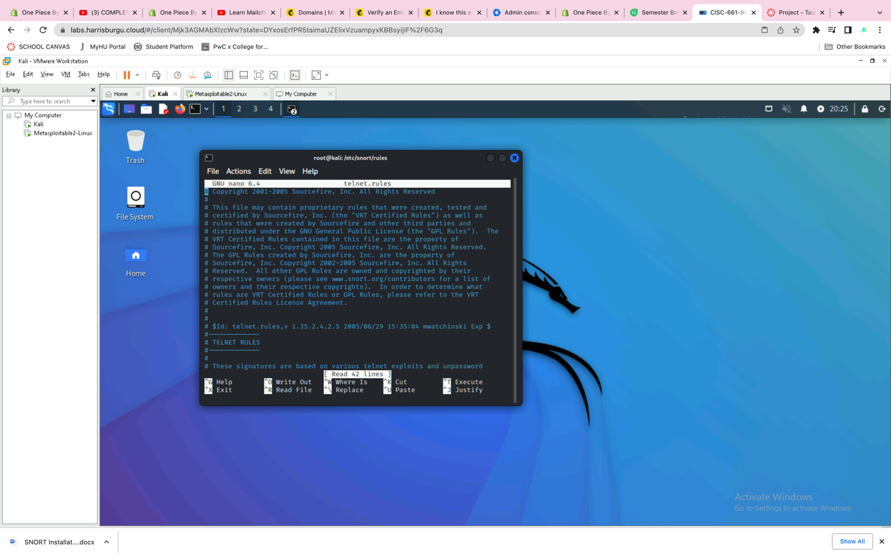

* Add command rule to alert tcp

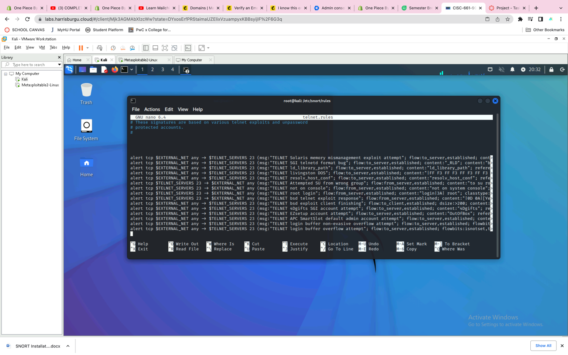

* Start display information from detection on our screen.

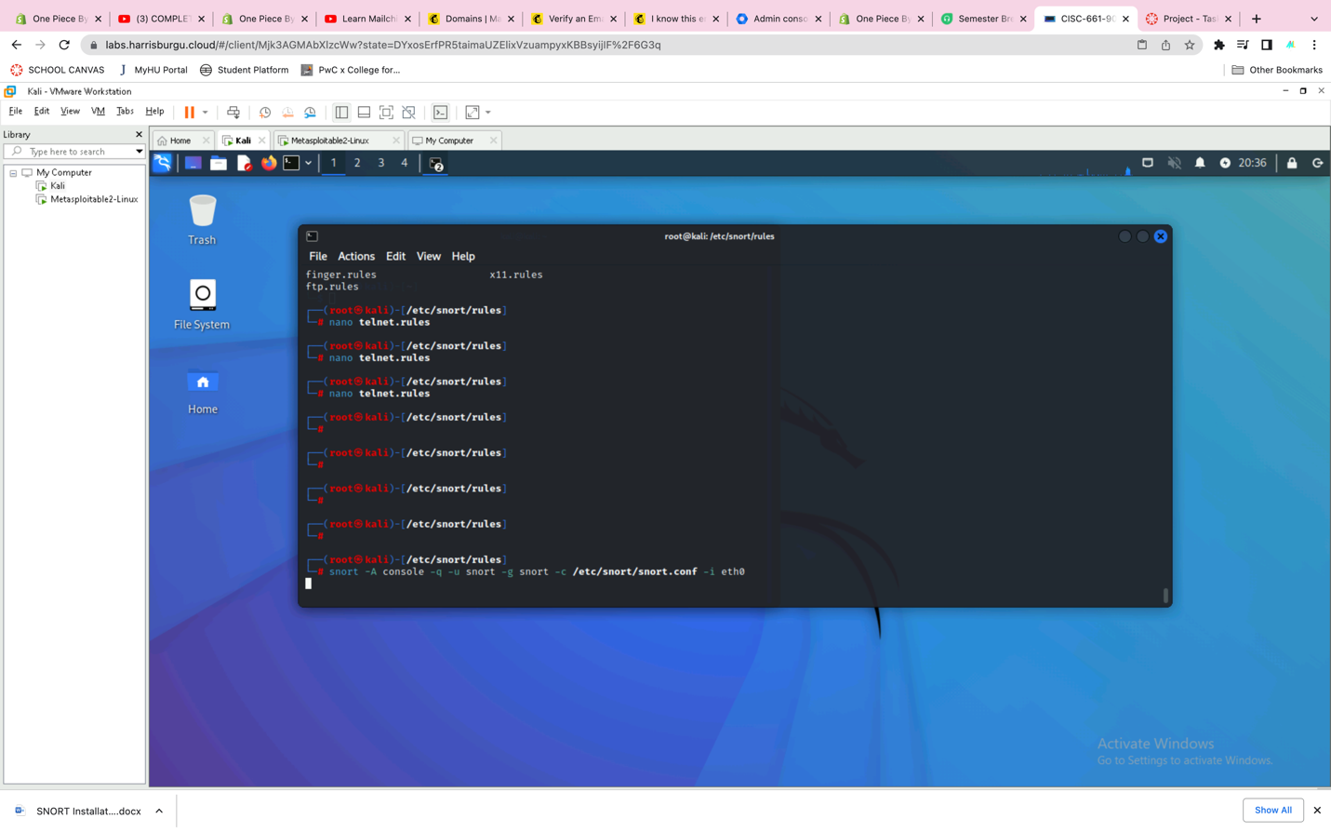

* Ping 10.10.1.10 on Metasploitable

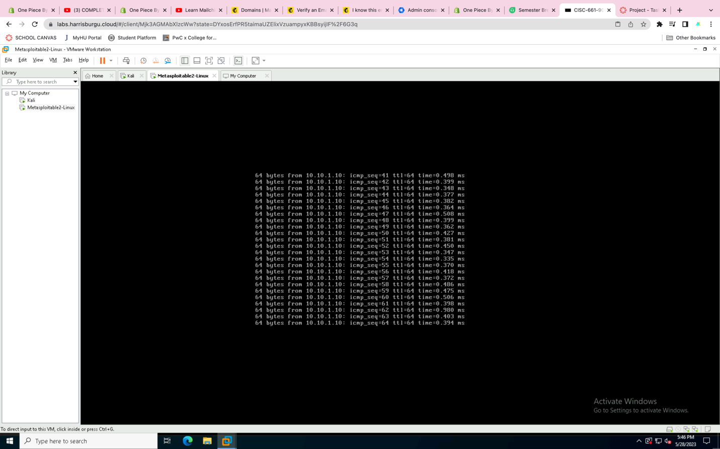

* Detection is then shown on Kali.

